IDEATION PHASE - Brainstorm & Idea Prioritization

|  |  |
| --- | --- |
| **DATE** | 10September 2022 |
| **TEAM ID** | PNT2022TMID08727 |
| **PROJECT DOMAIN** | Internet of Things |
| **PROJECT NAME** | IoT Based Smart Crop Protection System for Agriculture |
| **MAXIMUM MARKS** | 4 Marks |

**Brainstorm & Idea Prioritization :**

Brainstorming provides a free and open environment that encourages everyone within a team to participate in the creative thinking process that leads to problem solving. Prioritizing volume over value, out-of-the-box ideas are welcome and built upon, and all participants are encouraged to collaborate, helping each other develop a rich amount of creative solutions.

**STEP-1:** Team Gathering, Collaboration and Select the Problem Statement

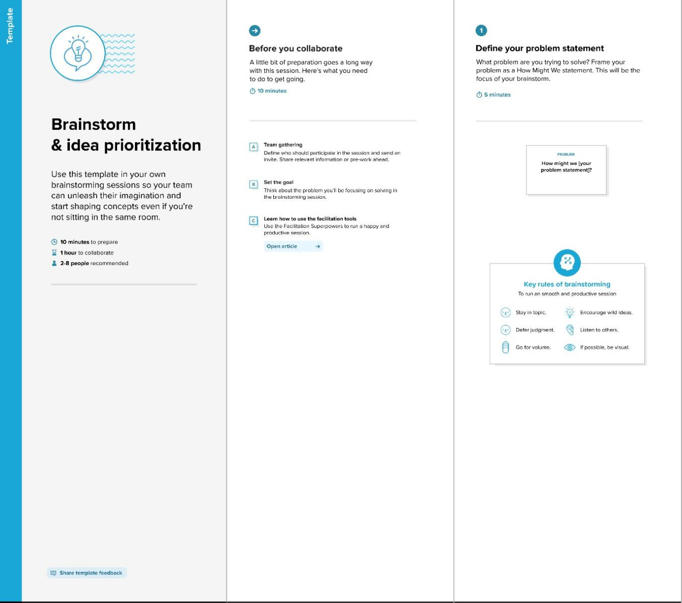

**STEP-2:** Brainstorm, Idea Listing and Grouping

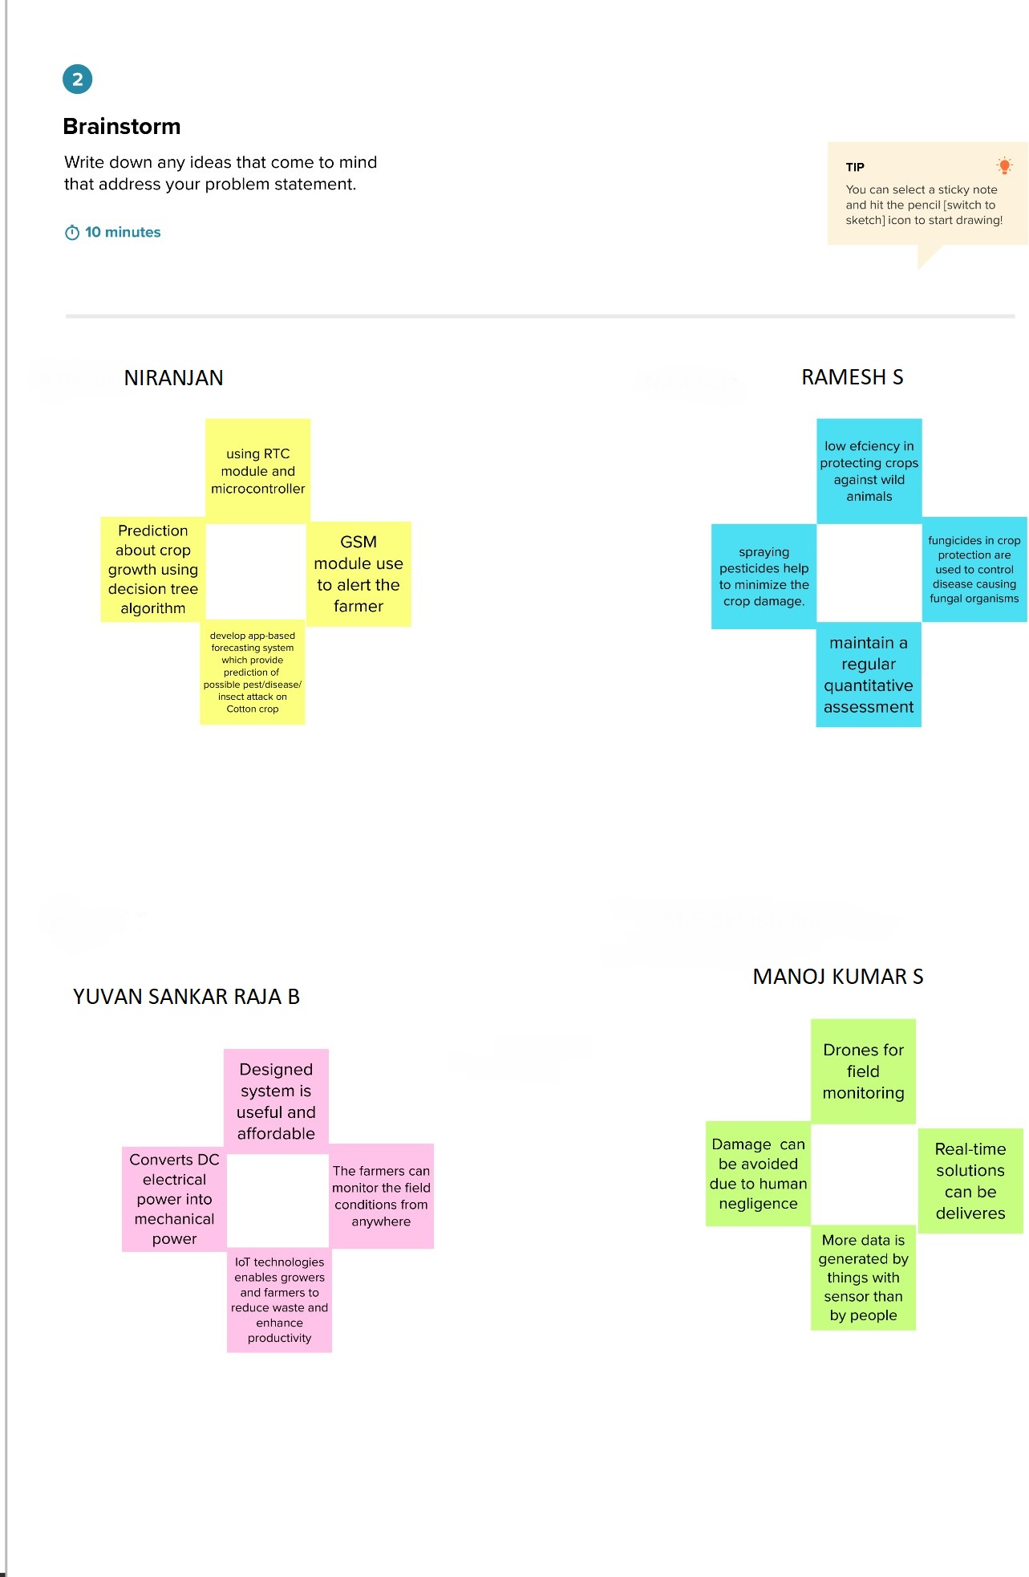

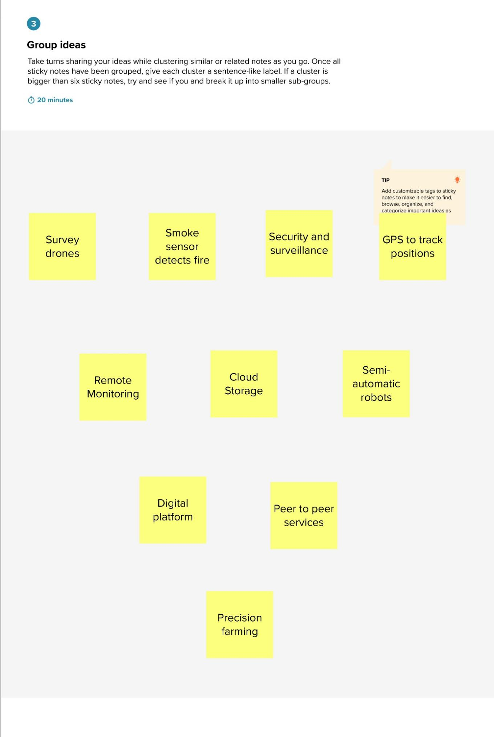

**STEP-3:** Idea Prioritization

